CPS209 Assignment 2:

Data Structure Simulator

Due Date: April 5 11:59pm

Objective: To practice using Linked Lists, Stacks, recursion, inheritance, frames, listeners, and standard documentation.

General Application: Simulate linked lists and a stack graphically.

Instructions:

Write a graphical application for drawing and linking railcars. The interface for the simulation should look something like the following:

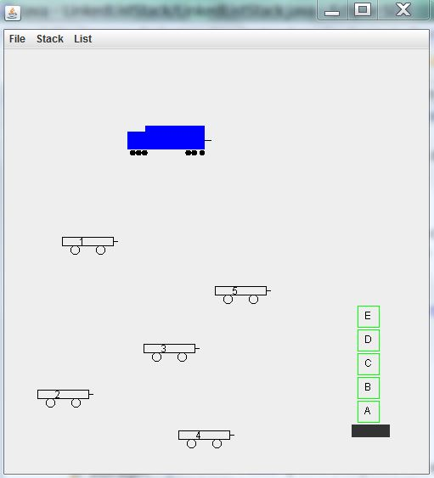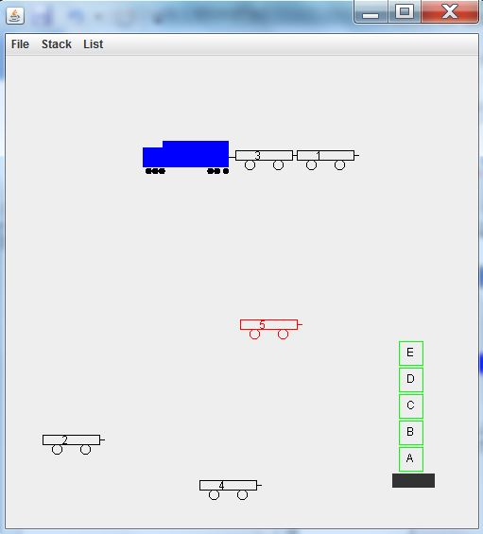
Figure 1: The figure on the left shows the panel after the user has pressed the mouse in seven locations to first create the train engine, then five railcars and then the stack of storage containers (with a base) shown. The figure on the right shows the panel after railcar 3 has been hitched to the train and after railcar 1 has been selected and hitched to railcar 3. Railcar 5 is currently selected. Note the line used to visually depict a vehicle’s trailer “hitch”.

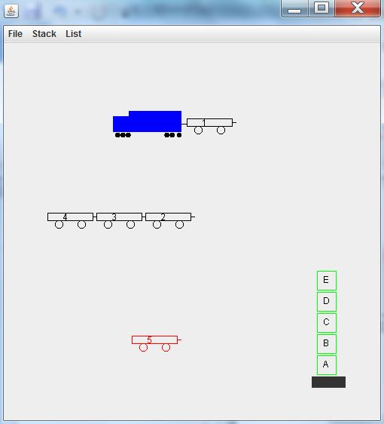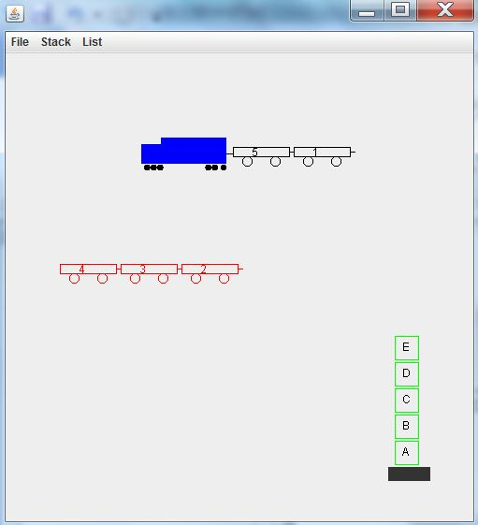

Figure 2: In the left figure, railcar 3 has been selected and hitched to railcar 4 and then railcar 2 has been selected and hitched to railcar 3. Railcar 5 is currently selected (indicated by the color red). In the right figure, railcars 4, 3, and 2 have been linked and then railcar 4 has been selected. This causes the trailer of railcar 4 (railcar 3) and the trailer of railcar 3 (railcar 2) to also be selected. The user can now move railcars 4, 3, 2 as a single unit.

Terminology:

• Vehicle: Abstract class which is a superclass of classes RailCar and TrainEngine. This class should contain variables and methods that are common to RailCar and TrainEngine. The methods supply default behavior and may be overridden in RailCar and TrainEngine.

• trailer: This is not a class, but rather just a term that refers to a railcar attached to the hitch of another vehicle. So, in figure 1 on the right, railcar 3 is a trailer for the train engine, and railcar 1 is a trailer for railcar 3. Class Vehicle should have an instance variable trailer of type Vehicle. This variable is set to refer to the towed vehicle object or is set to null (indicating there is no towed vehicle).

Functionality:

- You cannot use the mouse to select a towed vehicle. Only the lead vehicle can be selected. When a lead vehicle is selected, the vehicle and its trailer (and the trailer’s trailer etc.) move as a single unit. We will refer to a trailer railcar, and the trailer’s trailer etc. as the “linked railcars”.
- When you draw a vehicle, you must recursively draw its trailer (which will cause the trailer's trailer to be drawn, etc.).
Basic mouse operations are as follows:

• Press: Initially the panel is blank. The user can then press the mouse button and the train engine is created at the mouse position. Then, wherever they press the mouse button a railcar is created at that location. After five railcars have been created in this manner, then the next mouse button press creates a stack of 5 storage containers and a container base. Any subsequent mouse button presses on a railcar selects the railcar (and any linked railcars) and changes its (and any linked railcars) color to red.

• Drag: If the user presses and holds the mouse button and drags the mouse on a railcar which has been selected, then the railcar (and any linked railcars) moves with the mouse. You can look up MouseMotionListener in the java API to implement dragging. Note: the train engine can be selected and dragged, along with all of its linked railcars.

• Release: When you release the mouse button, if the bounding box of the selected railcar intersects the bounding box of another vehicle (railcar or train engine) which does not already have a trailer, then the selected railcar (and any linked railcars) becomes the trailer for that vehicle.

The File menu lets the user do the following:

• New: Start a new simulation.
• Exit: Exit from the application.

The List menu should let the user do the following:

• Add First: Link the selected railcar (along with any linked railcars) to the train engine as the first one in the chain of vehicles towed by the train engine.

• Add Last: Link the selected railcar (along with any linked railcars) to the last railcar in the chain of vehicles towed by the train engine.

• Remove First: Remove the first railcar from the chain of railcars linked to the train engine. The other railcars remain attached to the train engine. Position the removed railcar randomly.

• Remove Last: Remove the last railcar from the chain of railcars attached to the train engine.

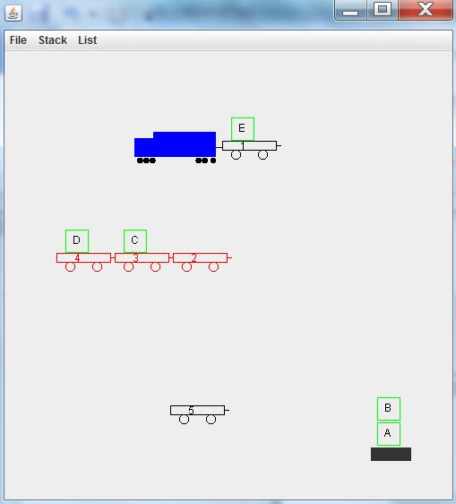
Figure 3: loading of railcars with storage containers from container stack

The Stack menu lets the user do the following:

• pop: pop the top storage container off of the container stack and load it onto the selected railcar only if the railcar is empty. If the railcar is not empty then check the linked railcars (i.e. traverse the linked railcars) for an empty railcar. If one is found, load the storage container onto it. If none is found, leave the container stack unchanged.
• push: unload the storage container from the selected railcar and push it onto the container stack. If the selected railcar is empty, traverse the linked railcars looking for the first nonempty railcar. If one is found, unload the container and push it onto the container stack.

Note: if the train engine is selected, apply pop and push to its linked railcars

NOTE WELL!!:
The train engine and railcar part of this assignment is a linked list simulator. This means *you must manage the linked list yourself* by setting a vehicle's (i.e. a railcar or the train engine) trailer variable to refer to the car object you want to attach as a trailer. Do not use the java LinkedList class to do this.
Also, when your paintComponent() method is executed, you must draw the train engine and the 5 railcars. However, inside paintComponent() you only call the draw() method for a railcar *if it is not a trailer* (of the train engine or of another railcar).
If a railcar is a trailer of the train engine or of another railcar, then the recursive draw method of class RailCar/class TrainEngine will draw it.
So, if you refer to figure 2 left, your paintComponent() method should call the draw() method for the train engine and for the lead railcars 4 and 5. RailCars 1, 3, 2 will be drawn via the recursive draw method.
You might want to keep a separate ArrayList of the 6 vehicle objects inside your
JComponent/JPanel class. When paintComponent() is executed, it gets a vehicle
from this arraylist and only draws it if it is not a trailer (Hint: a vehicle could use a boolean instance variable, isTrailer, to keep track of its trailer status).

For the container stack part of the assignment, you must either use the java Stack class or manage the container stack yourself with links (similar to the railcars above).

Sample files that may be useful to extend and modify:
RailCar.java (based on class Car from BigJava)
TrainEngine.java

Sample files that may be useful as an example or guide for GUI menus:
FontViewer.java (From Chapter 19 of BigJava)
FontFrame.java (From Chapter 19 of BigJava)

Grading Details:
- For a maximum of 6 marks do all of the above except no mouse functionality and no container stack push/pop functionality. Automatically create the train engine, the five railcars and the container stack and place them randomly in the panel.
- For a maximum of 7 marks, add the mouse press functionality.
- For a maximum of 7.5 marks, add the mouse drag functionality.
- For a maximum of 8.5 marks, add the mouse release functionality.
- For a maximum of 10 marks, add the container stack push/pop functionality.
- Note that 10% of your mark is for program structure, style and documentation. You must use inheritance. You must use javadoc style documentation, have proper indentation, meaningful variable names, class names starting with uppercase, variable names starting with lower case, constants all capitals.
- Submit your java files on Blackboard by Apr. 5

Copying or letting your work be copied results in a zero as well as other repercussions.

